**COS10026 – Computing Technology Inquiry Project**

**Assignment 2 – Individual Report**

Student Name: Nguyen Dinh Dung

Student ID: 104772138



Table of Contents

Introduction 2

The Website 3

Security of the website 29

Your Contribution 32

Reflection and Discussion 32

Conclusion 34

References 35

# Introduction

1. Website Introduction

* Welcome to Corporate. We are a team including three members which are me-Dinh Dung, Thanh Thanh, and Quang Thai. In this project, we have created a website in a Scenario in which our company- Corporate, wants to advertise for 3 vacant positions: Front-end developers, Back-end developers, and Machine learning operators. Our website contains these main pages: Home page (index.php), Jobs page (jobs.php), Job application page (apply.php), About page (about.php), Login page (login.php), Sign Up page (sign_up.php), Manage page (manage.php), Profile page (login-done.php), and 9 other Job details pages ( front-end/1/2.php, back-end/1/2.php, ML-ops/1/2.php ). The Job details page focuses on those 3 jobs, just different in location and salary.

1. Objective

* This report aims to demonstrate our skills in PHP, HTML, and CSS; and shows some problems that we faced while doing this assignment. In this assignment, I have made 2 enhancements to the website and I will demonstrate its details below in this report.

# The Website

1. index.php

* This HTML page is designed to showcase job opportunities, company information, and the organization’s focus areas. It features a responsive layout with a clean design, incorporating a header with navigation links to different sections such as *Home*, *Jobs*, *Apply*, *About*, and *Login*.
* **Key Sections:**
  + **Header and Navigation**:
    - Includes links for easy navigation.
    - Features company branding with a logo and social media links.
    - Consistent menu link between every page.
    - All meta tags are filled with pieces of information to ensure that this website is created entirely by us.



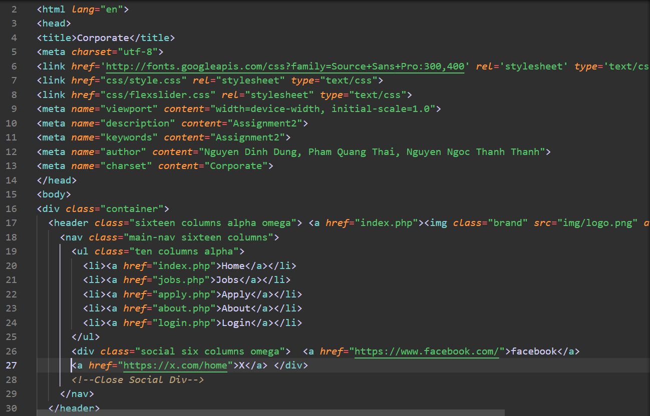*figure 1: Header and meta tags*

* **Feature Section**:
* Contains a slider with a video introduction and featured images, providing an engaging visual element. This slider uses JavaScript to automatically move to the next image. However, this does not affect the main page even if it is disabled because this is just an available library of JavaScript, not hard code.

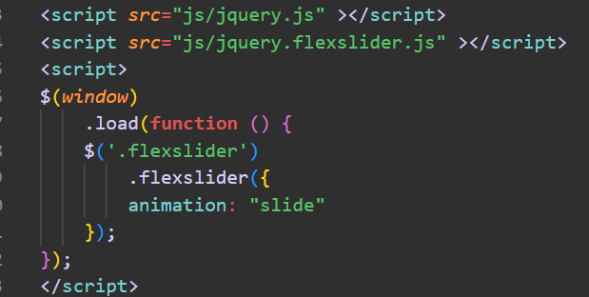

*figure 2: Java script slider*

* **Job Listings**:
* Highlights three job roles: Front-End Developer, Back-End Developer, and Machine Learning Operations.
* Each listing includes key details such as job requirements, location, and salary.
* Each job’s window when being hover will display its information.
  + Opacity: 0 will hide these details element
  + Transition: Smoothly animates changes in opacity and transform over 0.75 seconds.

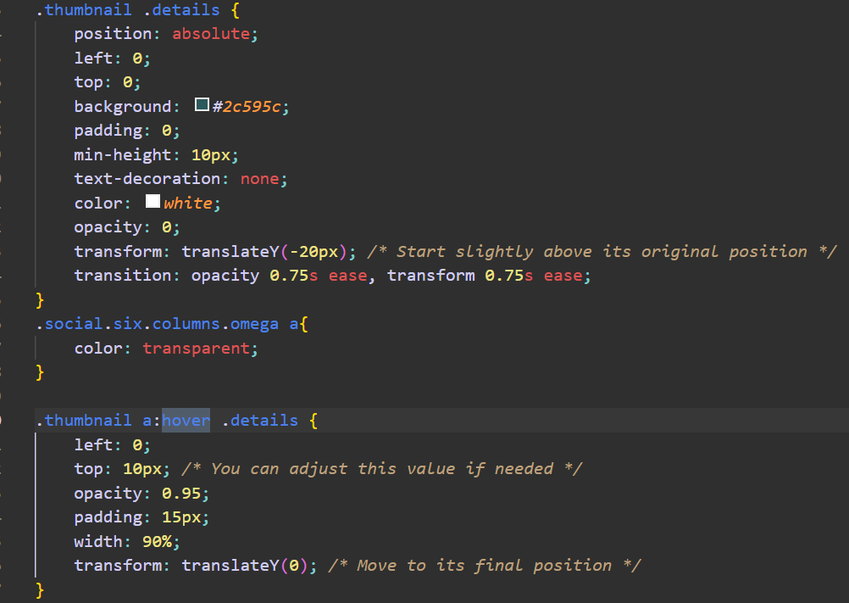*figure 3: Latest Jobs and hover function*

* **About Section**:
* Introduces the company, emphasizing its innovation in software and hardware solutions.
* Mentions partnerships with major companies like Amazon and Slack. These partner’s icons are animated to slowly show up and display as the user moves into this page.

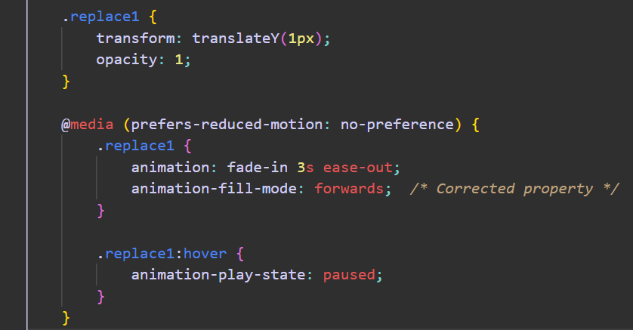*figure 4: animated partner’s icons*

* **Team Roles**:
* Describes key roles such as Web Designers and Software Engineers, showcasing their contributions to the company’s vision.
* **Footer**:
* Provides site navigation, copyright information, and the menu.
* As the header, the menu in the footer is consistence.

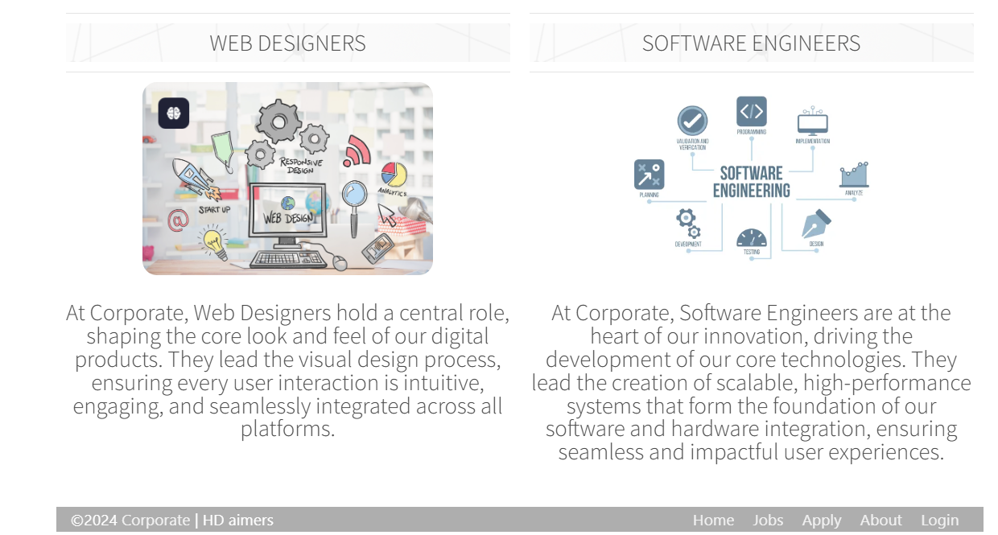*figure 5: Key roles and footer*

* **Technology and Features:**
* Uses **HTML5**, CSS, and JavaScript for structure, styling, and interactivity.
* Includes external libraries for fonts and sliders, like Google Fonts and Flexslider.
* Responsive and interactive elements, such as a video, image slider, and hoverable job details.
* This page acts as a comprehensive introduction to our corporate brand while serving as a portal for prospective employees and visitors to explore opportunities and learn about the company.
* Every page on this website is well designed and can be viewed from any device.

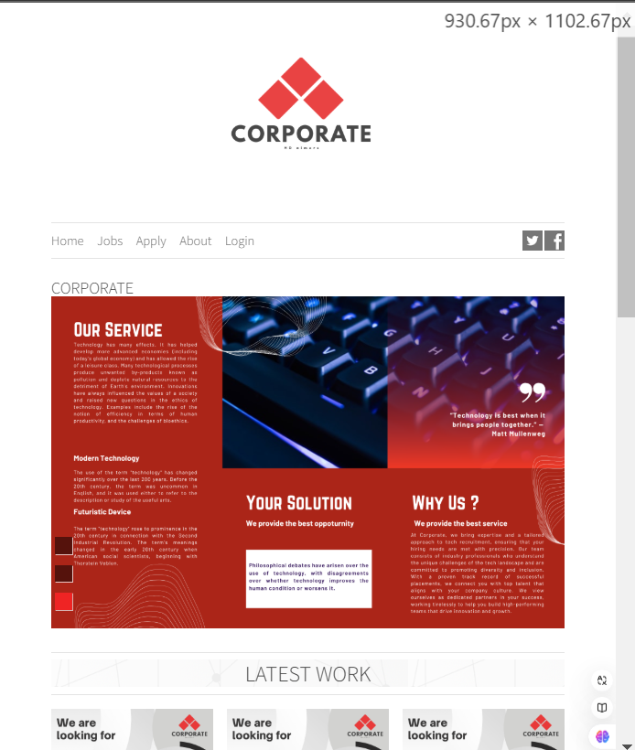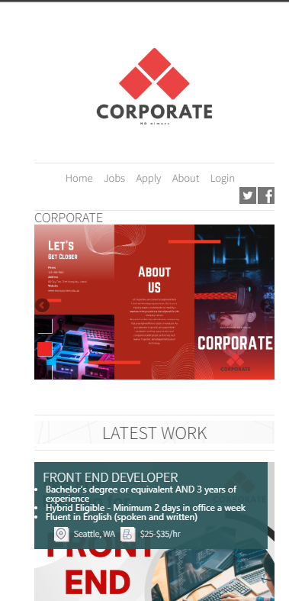*figure 6: Mobile and tablet layout (responsiveness)*

1. jobs.php
   * This page is the main page to demonstrate all of our 3 main jobs: Front-end developer, Back-end developer, and Machine Learning Operator; divided into different regions that contain a total of 9 jobs. This page has the hover functionality works exactly the same as the home page I showed previously.
   * Otherwise, everything still the same, the header, footer and logo.

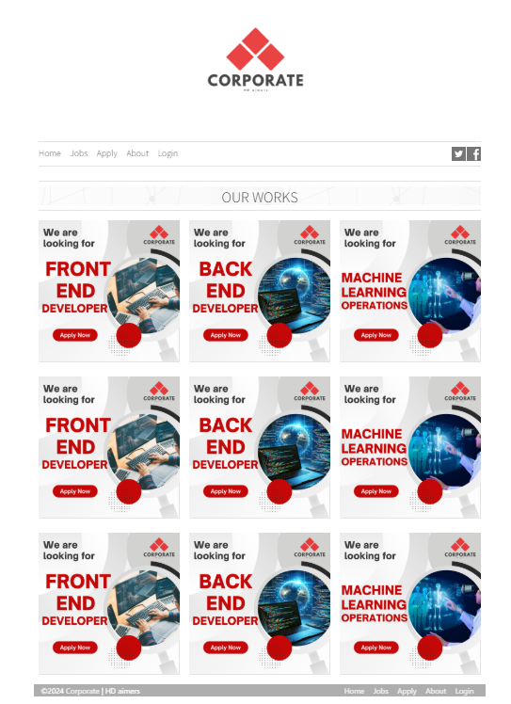

*figure 7: Jobs.php*

1. front-end(1,2).php
   * These pages will be my **enhancements** to the website where I display information dynamically by reading it from the database instead of hard code HTML.

**PHP Script:**

* Connects to a database using credentials from setting.php. ( I use Xampp for easier configuration )

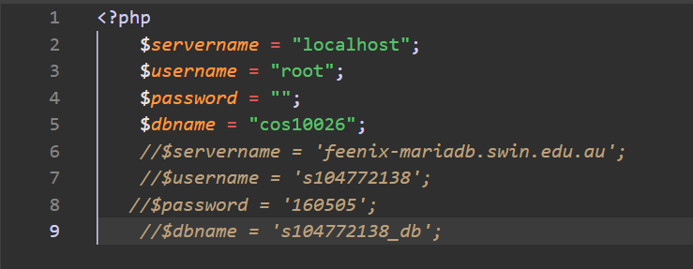

*figure 8: setting.php*

* Fetches job-specific data (location, salary, minimum requirements, preferred qualifications, and about the role) using an SQL query with a prepared statement to prevent SQL injection.
* Displays an error message if no job data is found.
* Queries the frontend_developer table for the fields location, salary, min_requirement, pref_qualification, and about_role for a specific job (WHERE id = ?).
* Prevents SQL injection by using prepare() and binding the $job_id parameter with bind_param().
* Dynamically formats and displays the job's hourly salary ($job['salary']).
* Uses number_format() for two decimal places and htmlspecialchars() for sanitization.
* Splits the min_requirement string into an array using explode('.') (assumes requirements are period-separated).
* Similar to the requirements section, but for pref_qualification.
* Displays the job's description using the about_role field.
* The same with other front-ends.php pages, just a difference in the data.

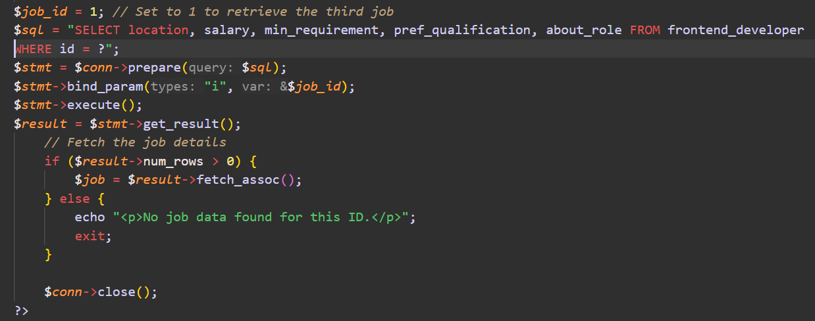  
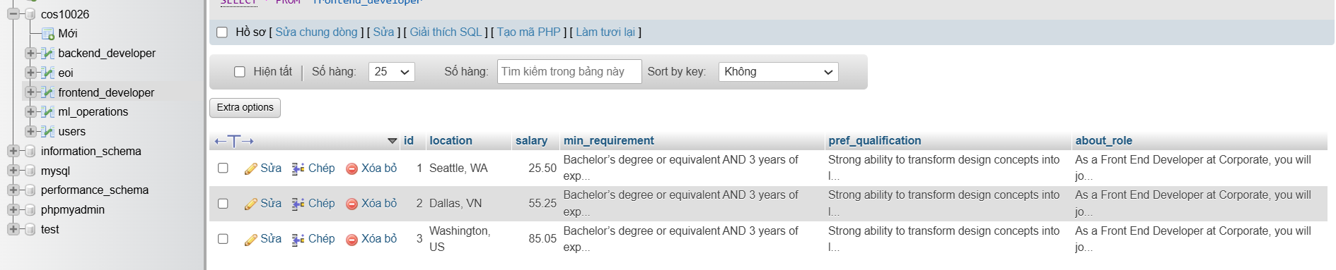*figure 9: choose job’s id 1 from the frontend_developer table to display*

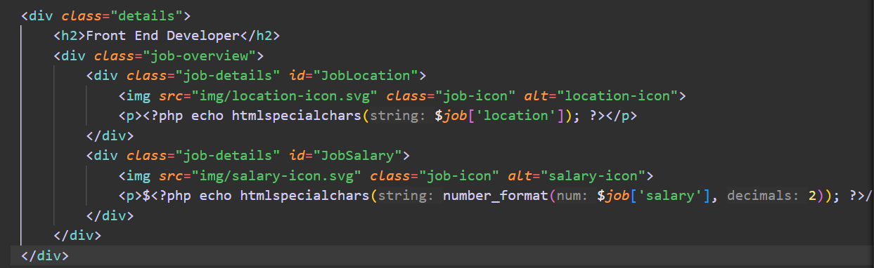

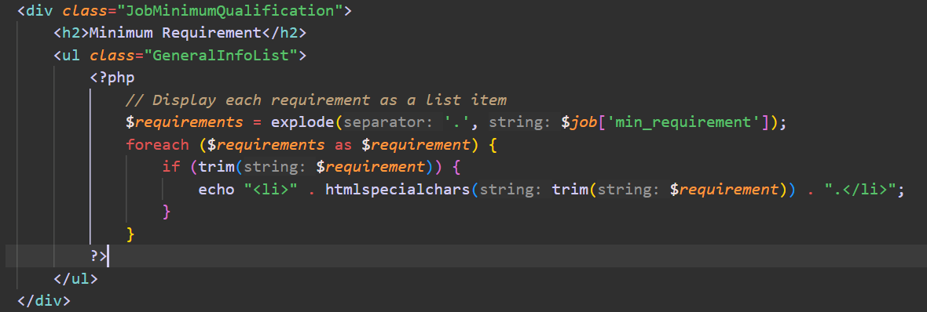

*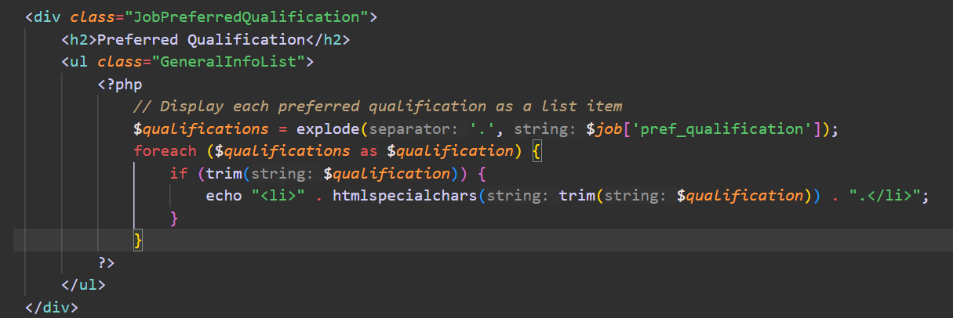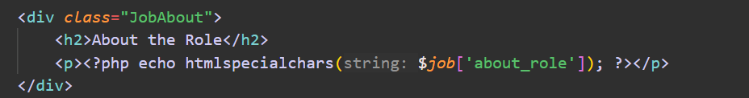figure 10: selected by the column name in the table and displayed in HTML code*

* Google map section:
* Embeds a Google Map iframe centered on Seattle, Washington.
* Uses iframe attributes for size, border, and lazy loading.
* Hover effect on the map and the button
* Adds a button to redirect the user to the apply.php page.

*figure 11: Front End Developer job’s details and hover effects*

1. back-end(1,2).php
   * These pages is exactly like front-end.php, except that it take data from table backend_developer instead.

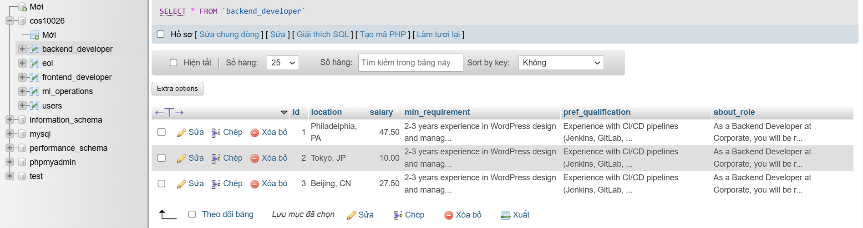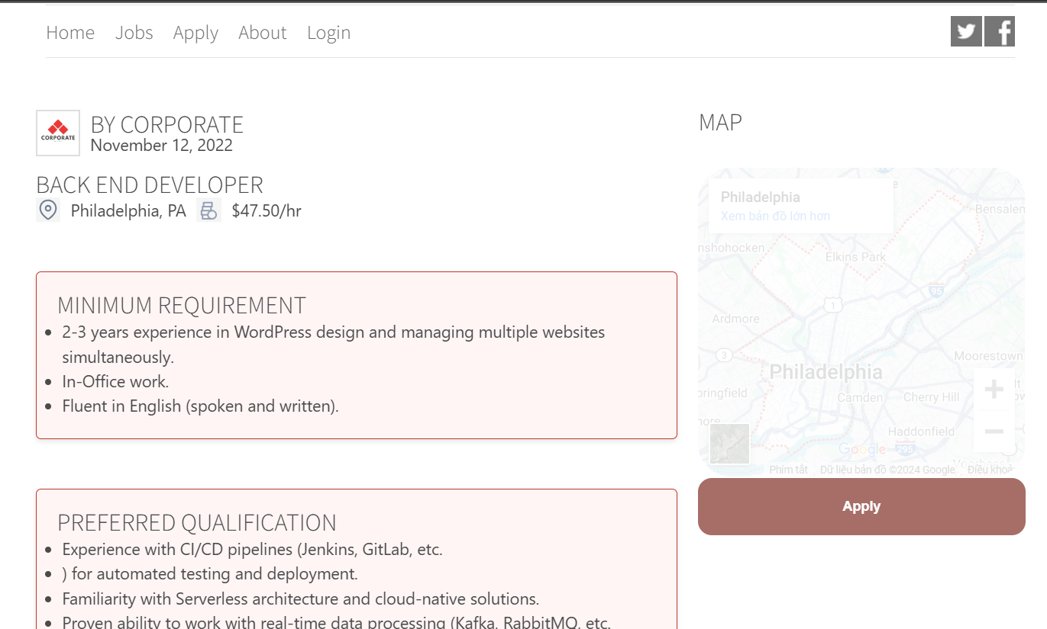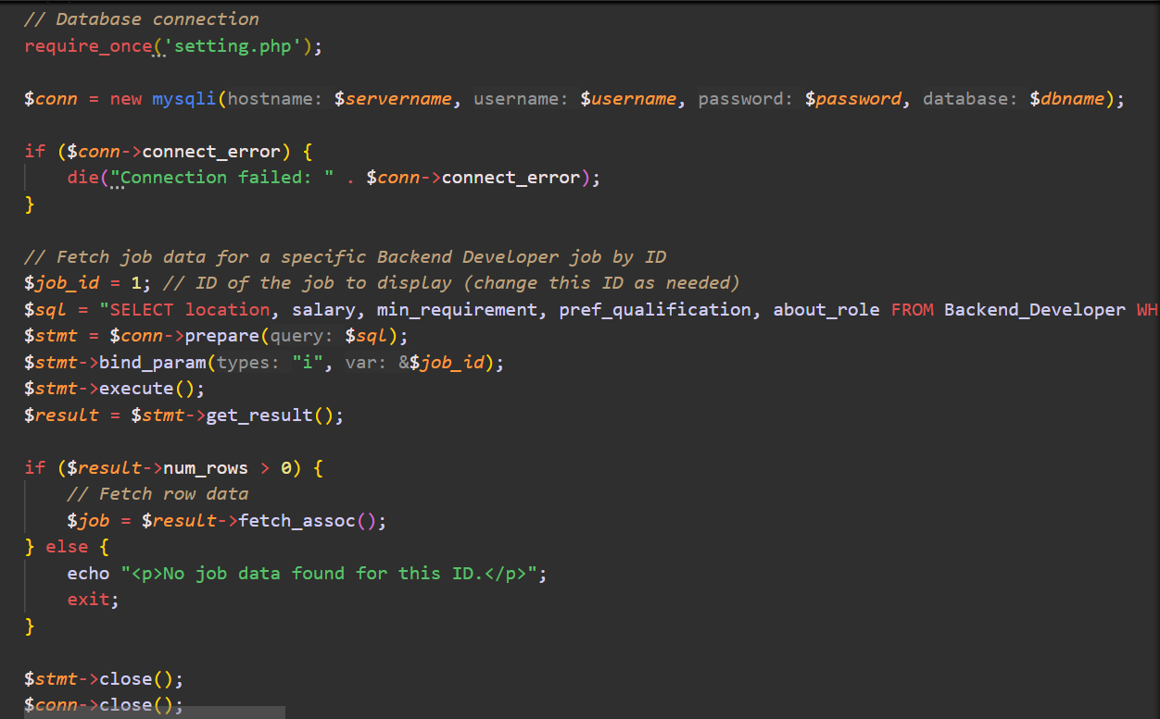*figure 12: back-end.php*

1. ML-ops.php
   * These pages are exactly like front-end.php, except that it takes data from table ml_operations instead.

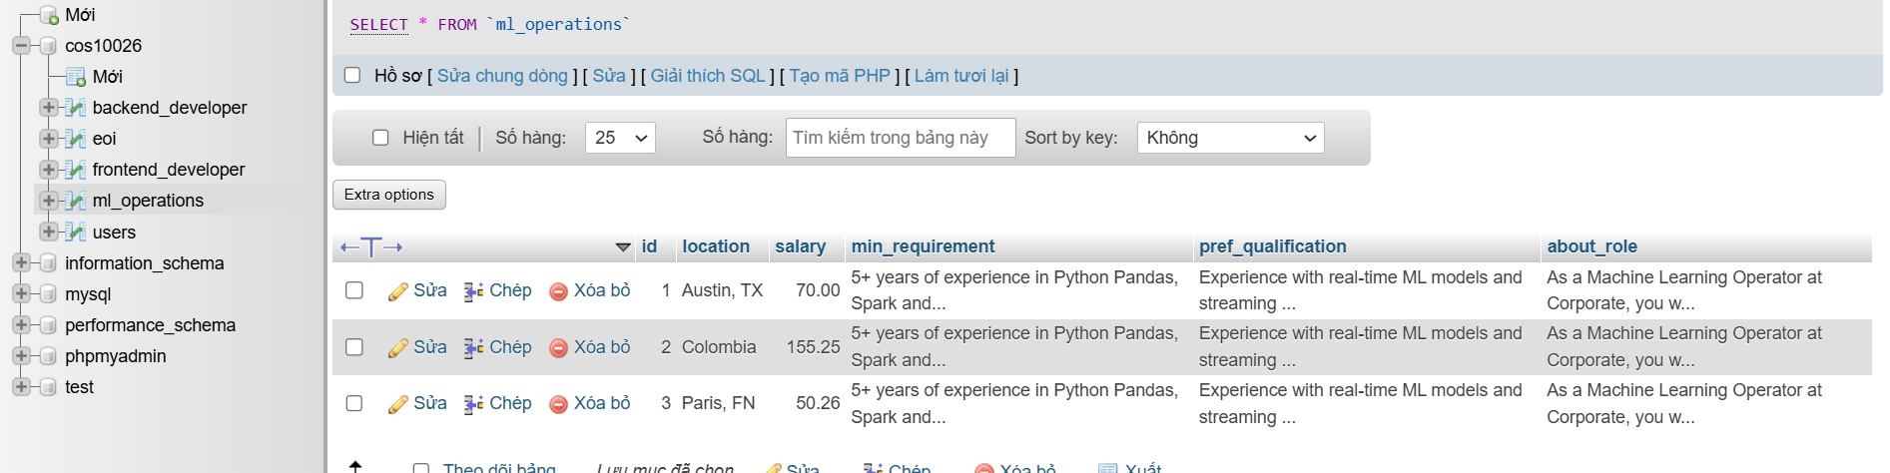

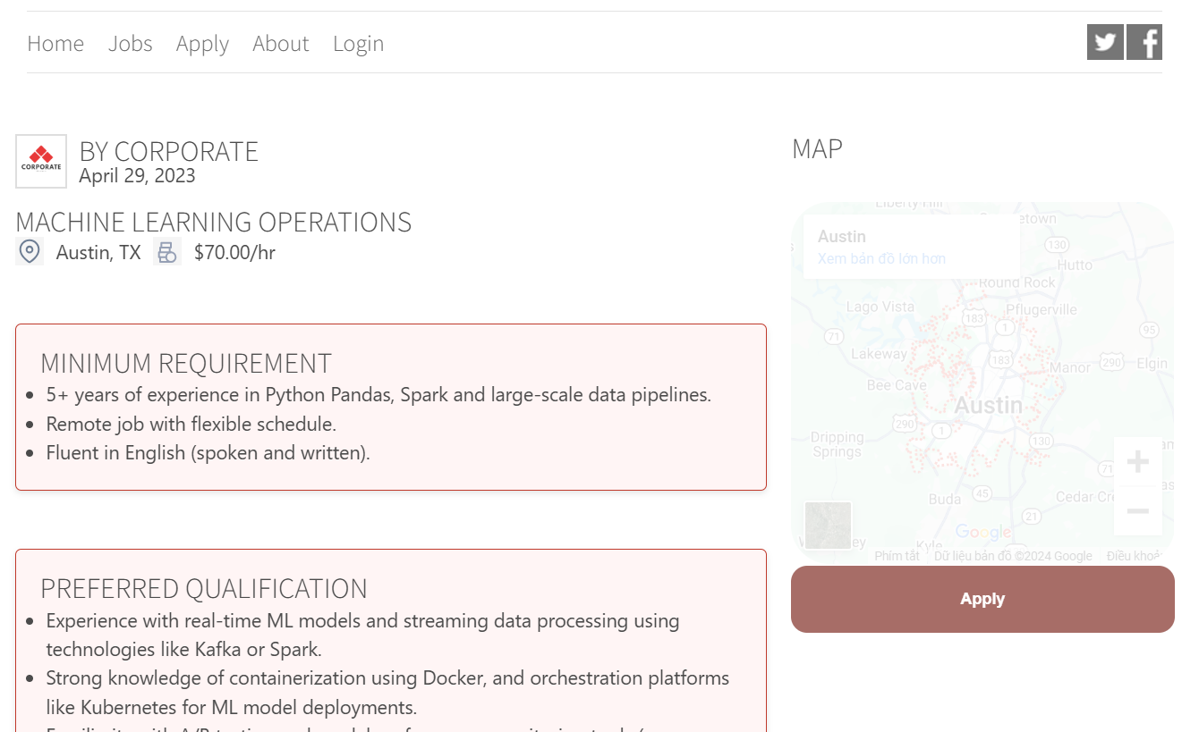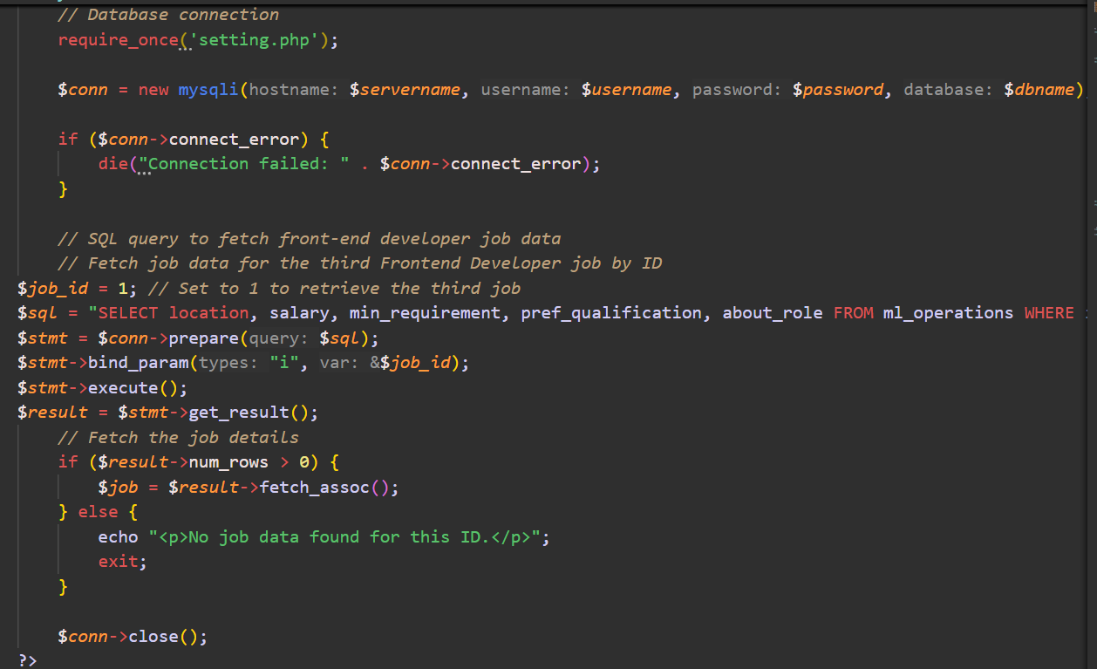*figure 13: ML-ops.php*

1. apply.php
   * This page contains a form with the required field and pattern on both the server side and front end. However, to test the functionality of the serverside validation, we disabled the front-end patterns.
   * After submitting, this page is no longer in charge of handling your request to the database but the processEOI.php file will.

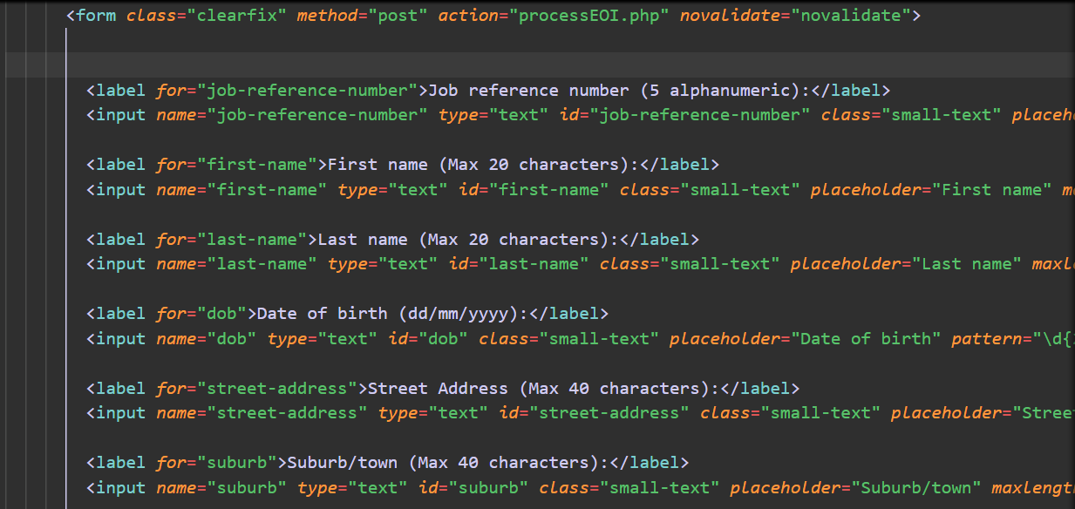*figure 14: disable HTML patterns and process with processEOI.php*

* processEOI.php:
  + Redirect if Accessed Directly:
    - Ensures this script is only accessible via a POST request (form submission).
    - Redirects to apply.php if accessed directly via URL.

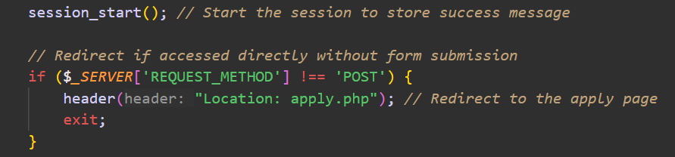

*figure 15: redirect method*

* Check and Create eoi table in the database

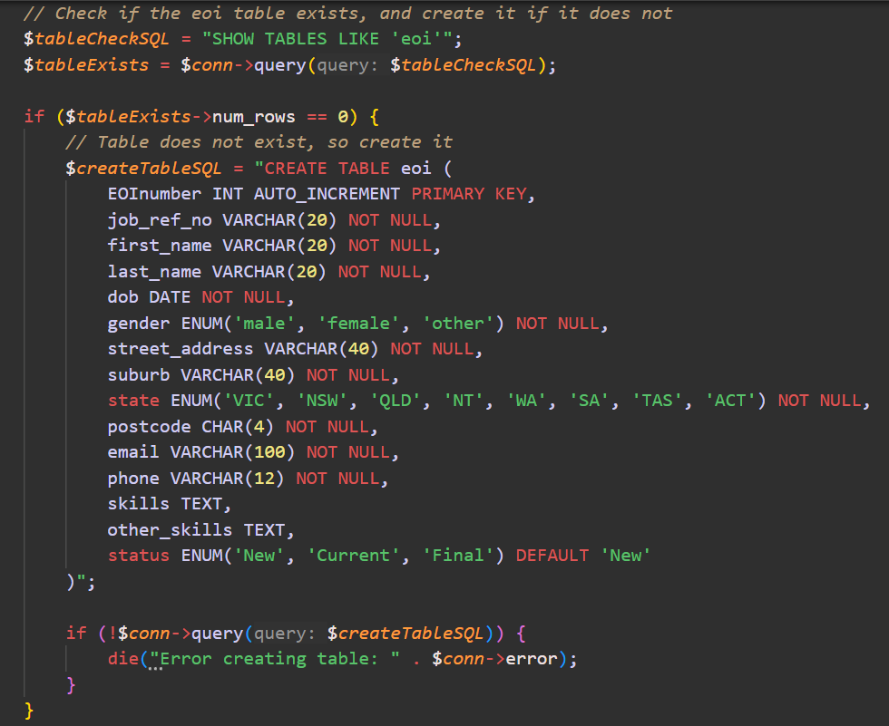

*figure 16: table checking and creation*

* Validation: Validates inputs using regular expressions, predefined values, and additional checks.

For example: Validates dob format and calculates the age (15–80).

if (!preg_match("/^(0[1-9]|[12][0-9]|3[01])\/(0[1-9]|1[0-2])\/(19[0-9]{2}|20[0-2][0-9])$/", $dob)) {

$errors[] = "Date of birth must be in dd/mm/yyyy format.";

} else {

// Convert and validate age

}

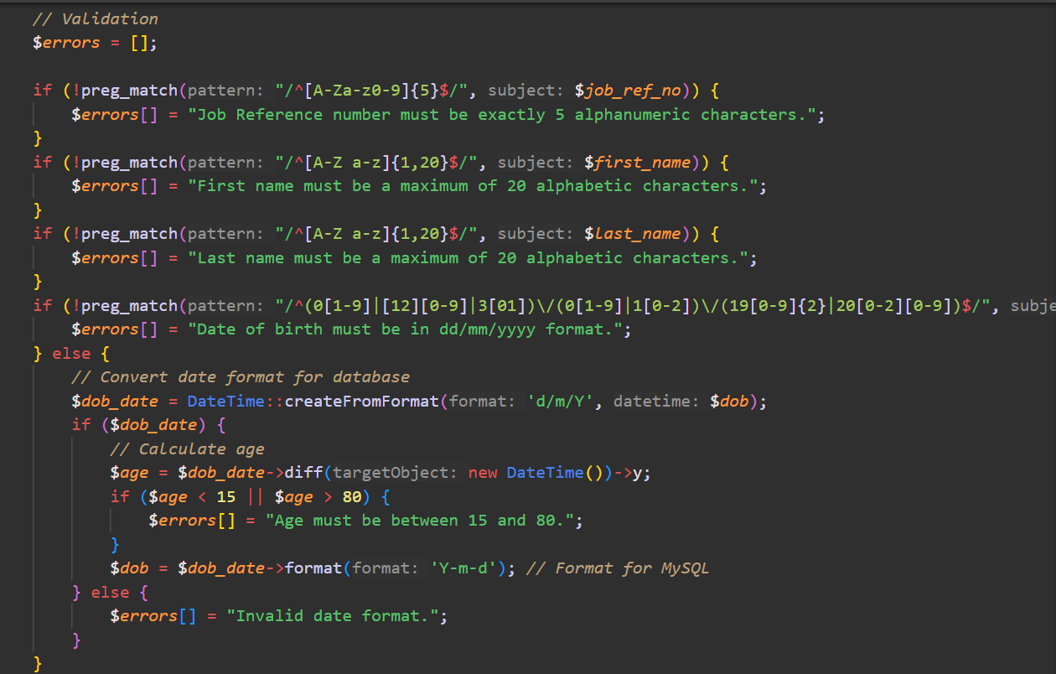

*figure 17: server-side validation*

* Error Handling: Displays validation errors and halts script execution. If the form is submitted successfully there will be a success message, otherwise, there will be errors. And if you see the message, just wait and it will automatically redirect you back to the homepage (if you login, otherwise it will direct you to the login page)

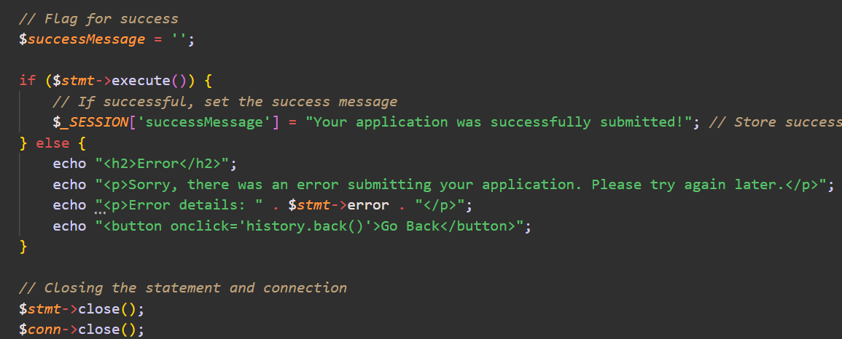

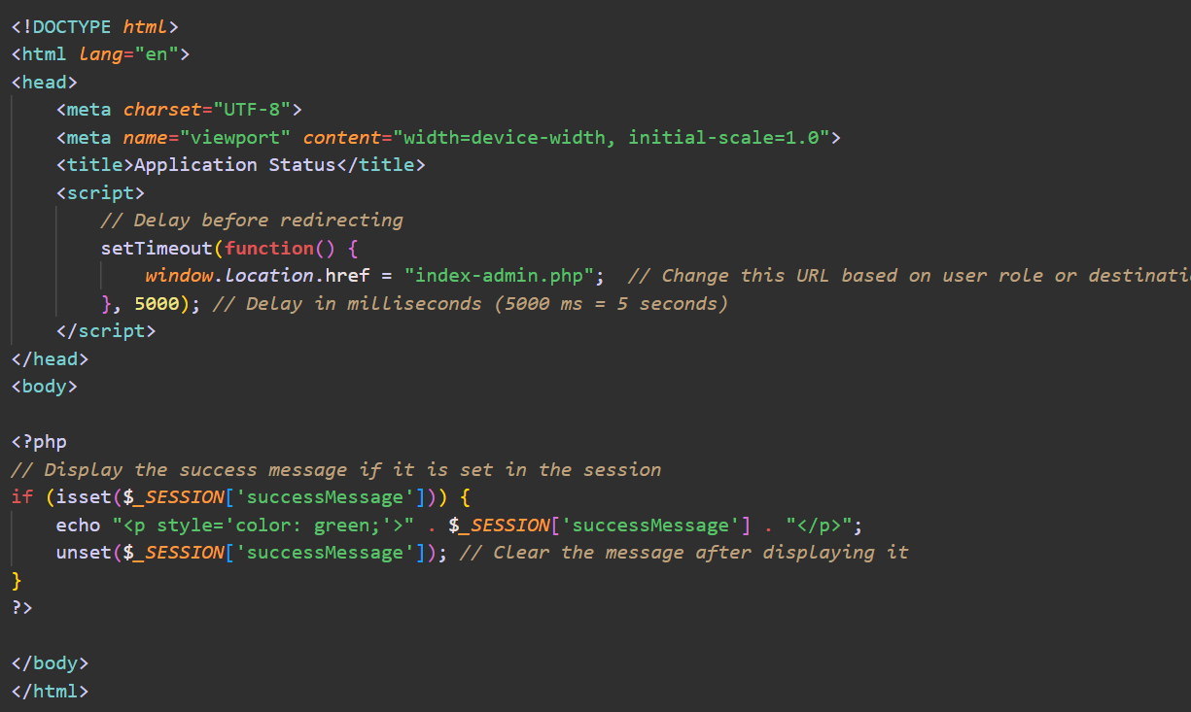

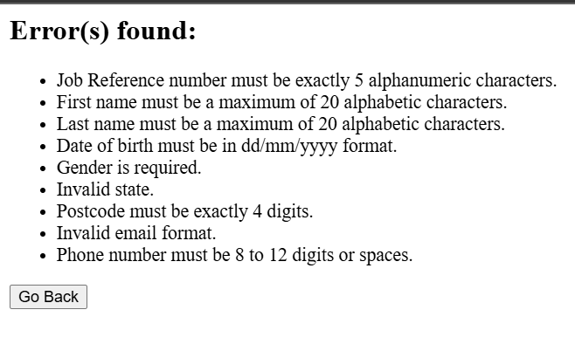*figure 18: error handling*

* Insert Data into the Database: Prepares an SQL INSERT statement and binds user inputs using placeholders to prevent SQL injection.

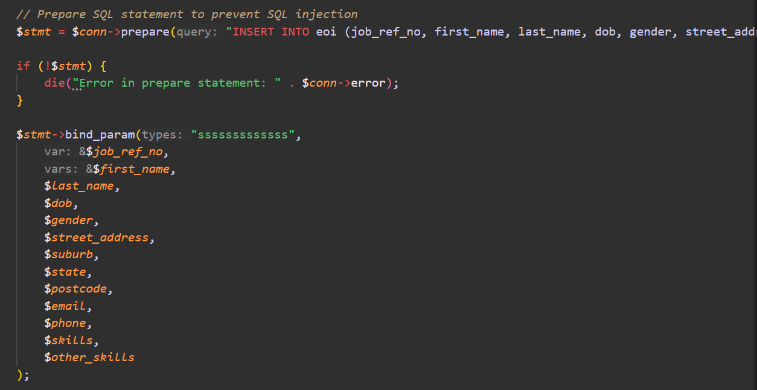*figure 19: Data Insertion*

1. about.php
   * This page displays our team information. I have implemented an image map of 3 of us so that when you click on one of us, you will moved to our section. Click on our profile image will move you to our Facebook, while clicking on our name will move you to mail to our email.

*figure 20: Image map*

1. login.php
   * This is another **enhancement** of mine in this project. This enhancement contains a large number of relative files so I will list this up.
     1. First, let’s walk through the login.php and sign_up.php
2. Login.php

* This is a PHP-powered login page that allows users to authenticate with a username and password. The code also uses a MySQL database to store user credentials.
* The colors on this page are entirely from CSS. Formed as decorative shapes.

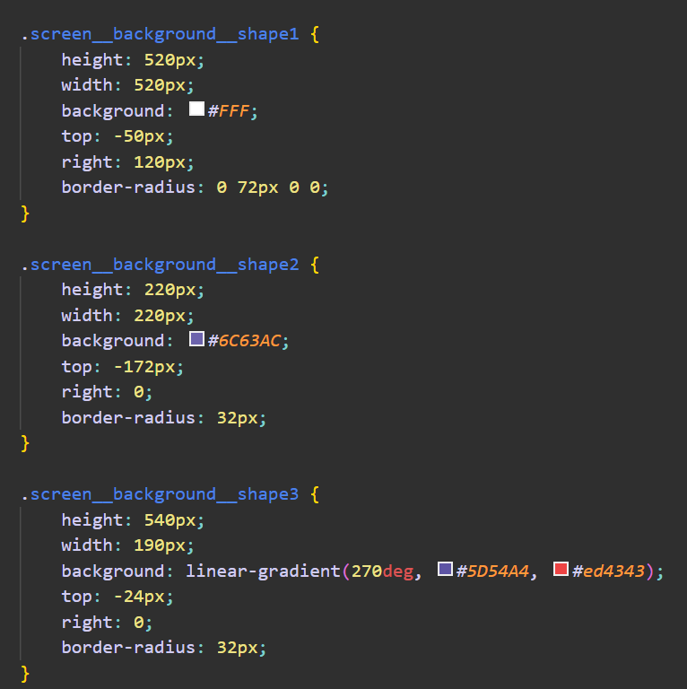

* Form Submission Check: Ensures the script only runs when the form is submitted via a POST request



*figure 21:*

* Retrieve Form Data: Retrieves the username and password values submitted from the form.

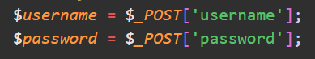

*figure 22:*

* Database connection: This file uses a direct connection instead of using a setting.php file because I want to avoid conflict between variable password and username in both files.

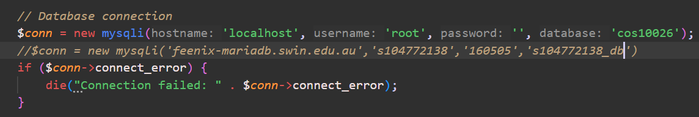

*figure 23:*

* User validation: Queries the users table to find a row matching the entered username.

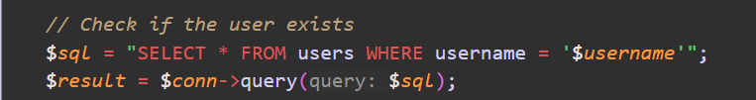

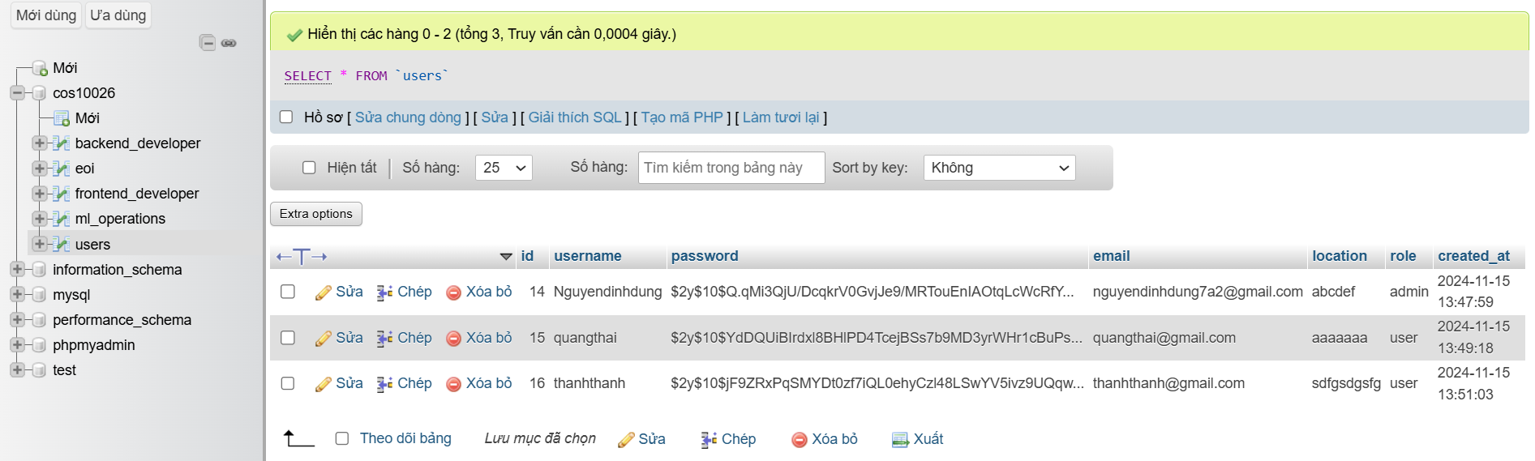*figure 24: users table*

* Check User Existence: If the username exists, fetches the user's details as an associative array.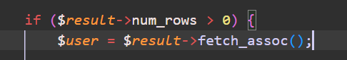

*figure 25:*

* Password Verification: Verifies the entered password against the hashed password stored in the database using PHP's password_verify() function.

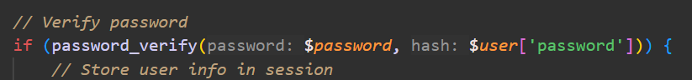

*figure 26:*

* Session storage and redirect: Stores the username and role (e.g., admin or user) in the session. Redirects the user to index-admin.php if they are an admin, or index-user.php otherwise.

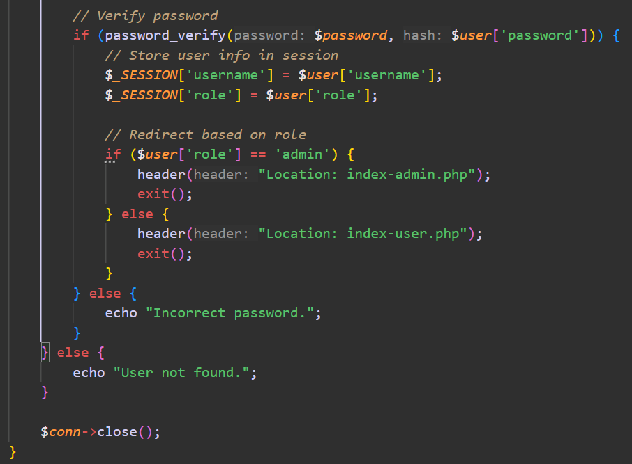

*figure 27: User validation*

* HTML: Each input field has a hover effect on it. The page also provides a sign-up option if you do not have an account yet. Click on the logo will get you back to the home page.

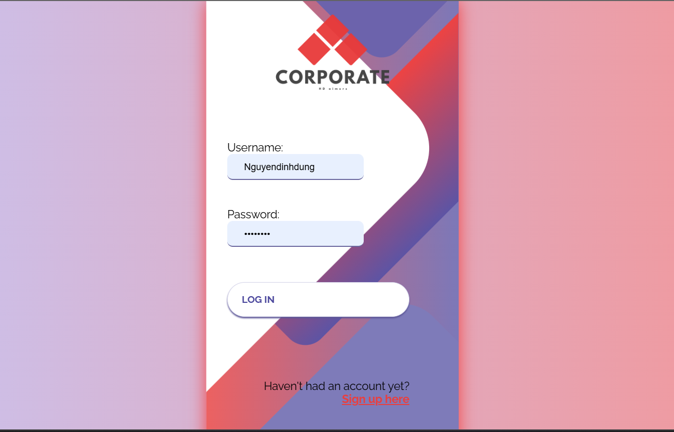

*Figure 28: Login.php*

1. Sign_up.php

* This page represents a **sign-up page** for creating new user accounts. It consists of an HTML form for user input and a PHP backend script to process the form submission.
* The front end looks exactly the same as the login page.
* The input field will allow you to choose your role: user or admin.

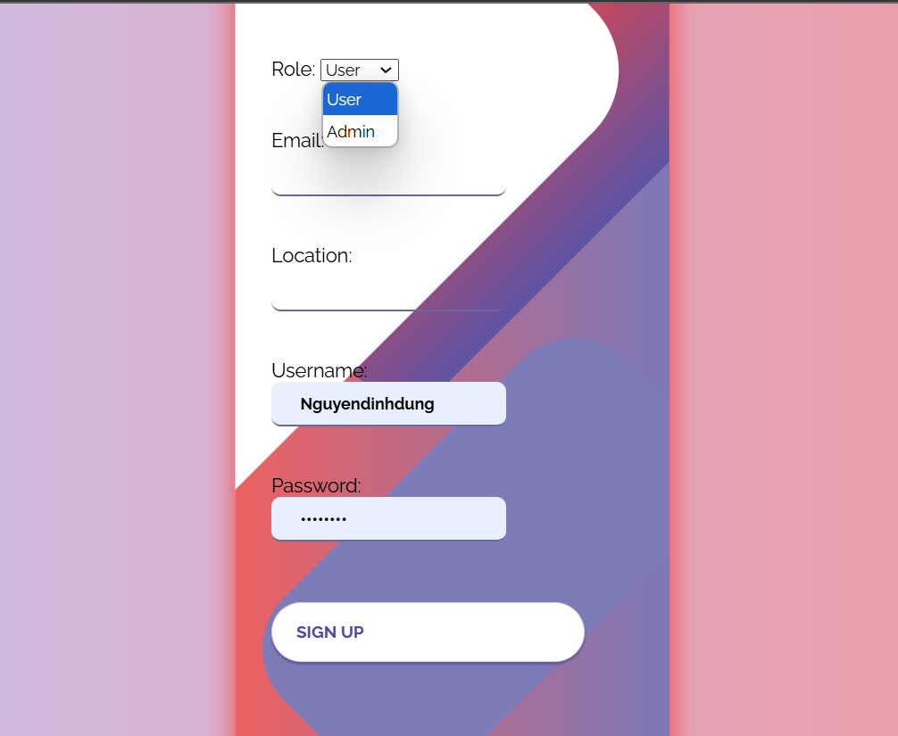

*Figure 29: Sign_up.php*

* Processing Form Submission:
  + **Checks Form Submission Method**:

The PHP script first verifies that the form was submitted via the POST method. If it wasn't, the script doesn't proceed with processing.

* + **Retrieve Form Data**:

Form input values (username, password, role, email, location) are captured from $_POST.

* + **Password Hashing**:

The user's password is securely hashed using PHP's password_hash() function with the default algorithm.

*figure 29: password hashed function*

* + **Database Connection**:

Establishes a connection to a MySQL database (cos10026) using mysqli. The connection parameters are hardcoded:

-localhost: The database host.

-root: The database username.

-'': An empty password.

-'cos10026': The database name.

(this is what I use for Xampp)



* + **Insert User into Database**:

An SQL INSERT query adds the user's data (username, hashed password, role, email, location) into a users table.

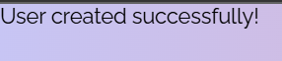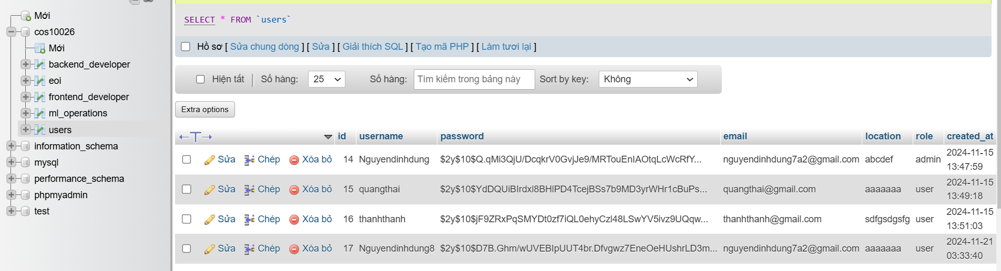*figure 30: users table after sign up form submitted*

* + 1. Index-user and Index-admin
* After login in, especially if you are an admin, you will see the welcome message and a manage tab which we will talk about later.

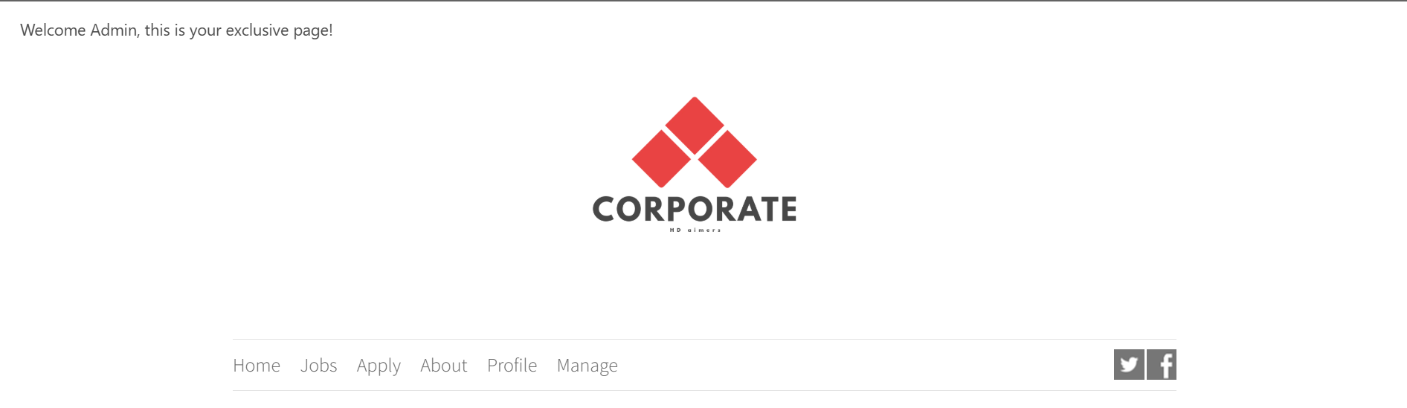*figure 31: index-admin.php*

* These 2 pages are the 2 pages you will be redirected to based on your role after you log in. When going into these pages, you can see there will be a profile page instead of a login page in the menu.

1. Login-done.php
   * This page will show your account information, and your profile ( what you have registered as), and show you the forms that you have submitted based on your email.

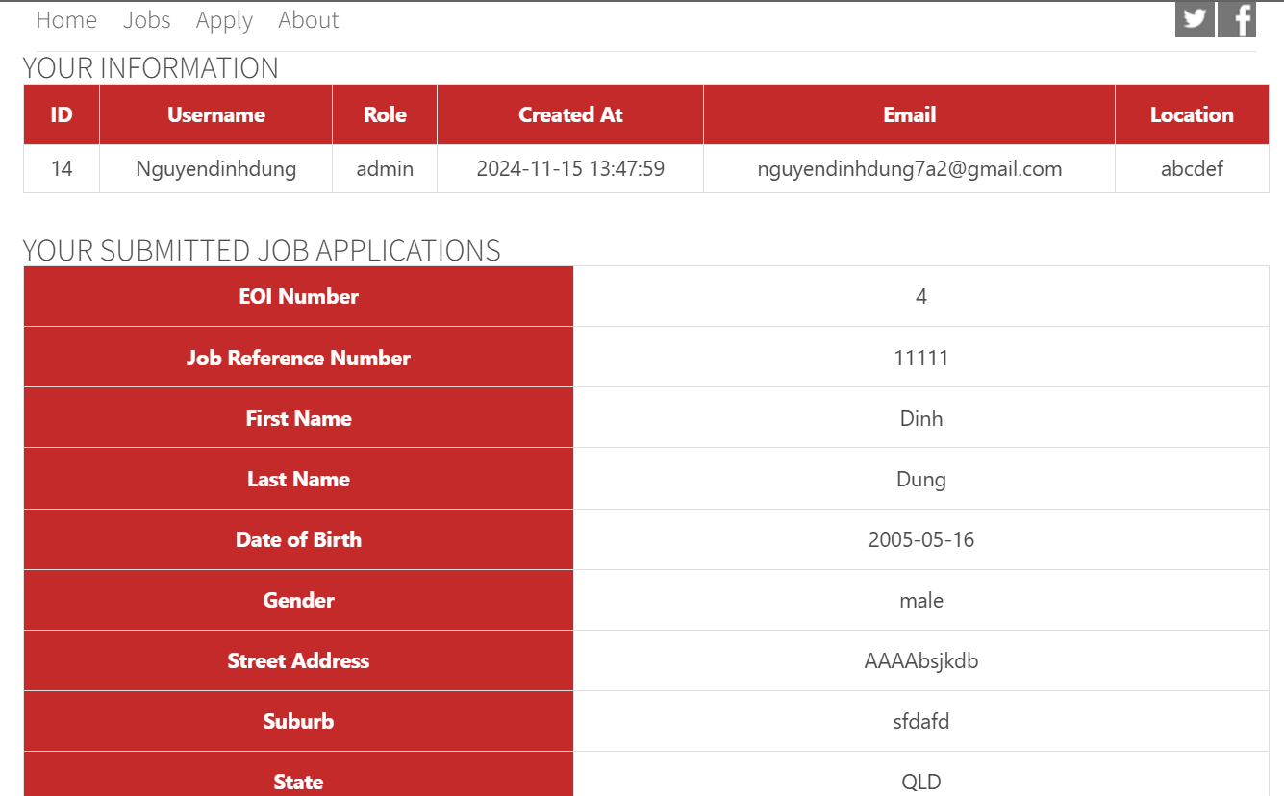*figure 32: user’s profile*

* Session Management: Ensures the page is only accessible to logged-in users. Uses session variables to personalize the content.
* User Details: Displayed in an HTML table using data fetched from the users table.
* Job Applications: Rendered in separate tables for each application using a while loop. Fetched from eoi table.

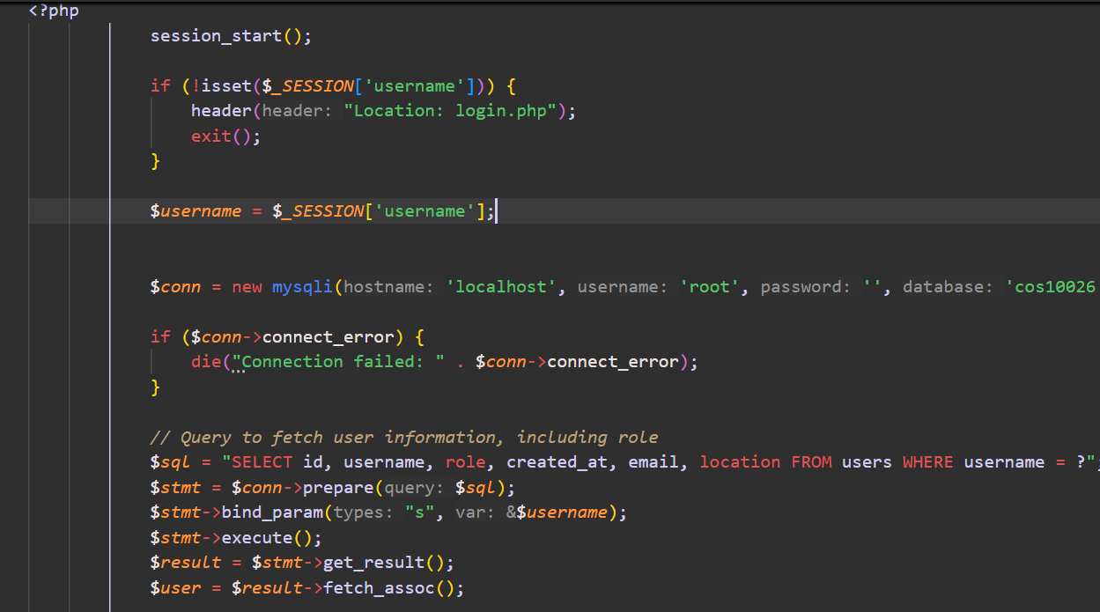

* At the end of the page, I provide you 2 options. If you click logout, it will lead you directly to index.php. But if you click go back, it will change the link based on your role to get you back to your home page associated with your role.



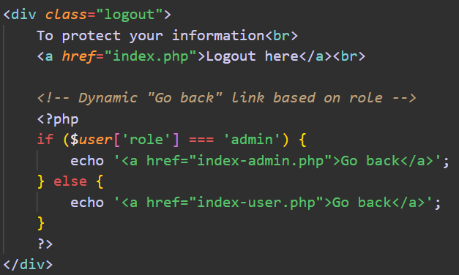

1. Manage.php

* This page contains of 5 active forms connected to the eoi table. You can search and change the status of each application here

**1. List All EOIs**

Retrieves and displays all EOIs from the eoi table.

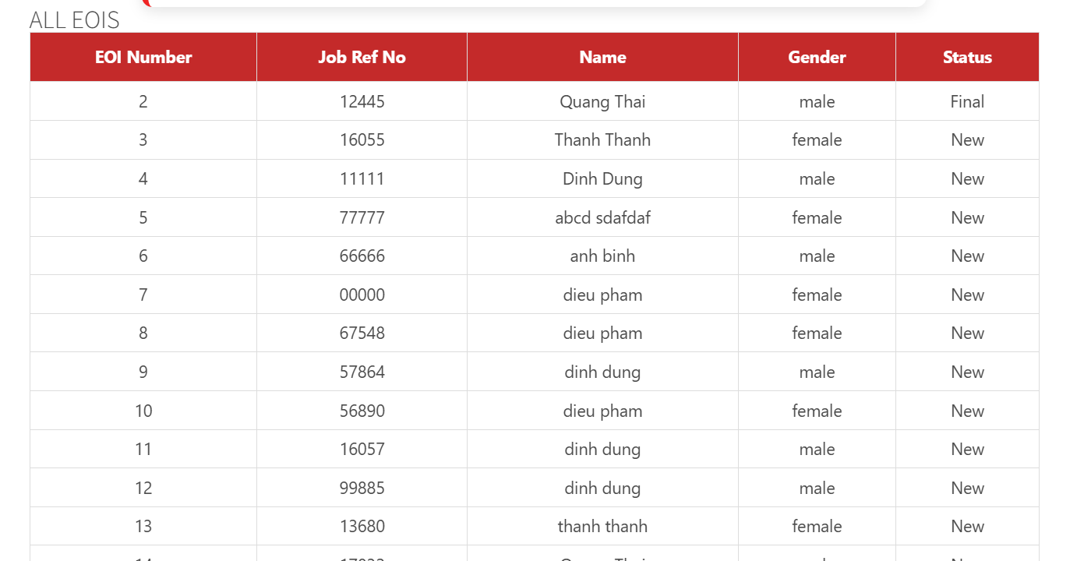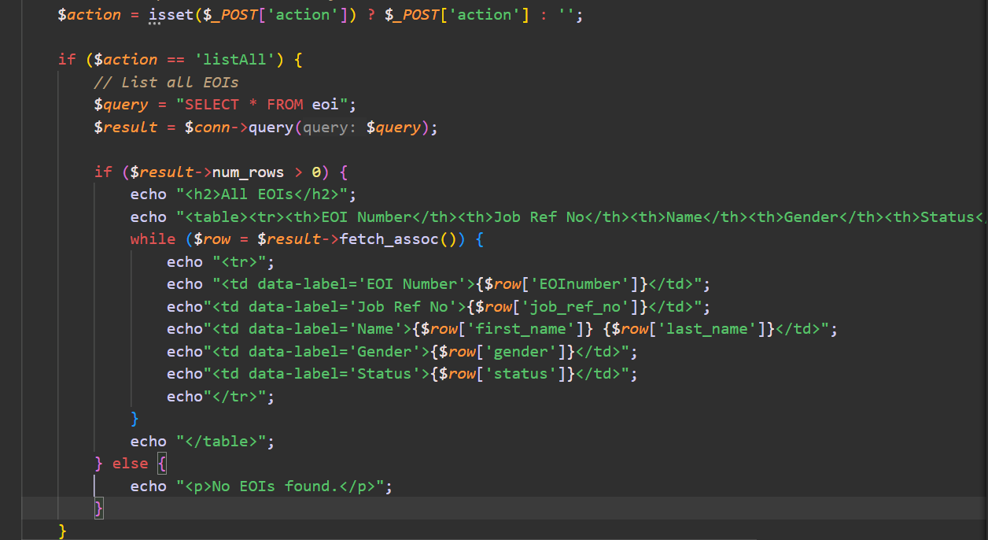

*figure 33:*

**2. List EOIs by Job Reference**

Searches the eoi table for records matching a specific job reference number. Displays results in a table.

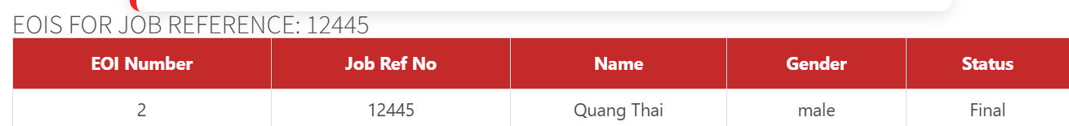*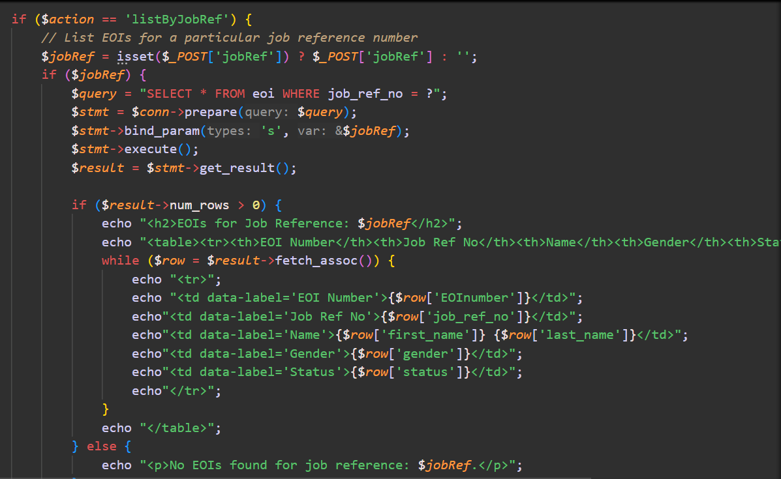figure 34:*

**3. List EOIs by Applicant Name**

Searches EOIs using first_name and last_name (with wildcard matching % for partial searches).

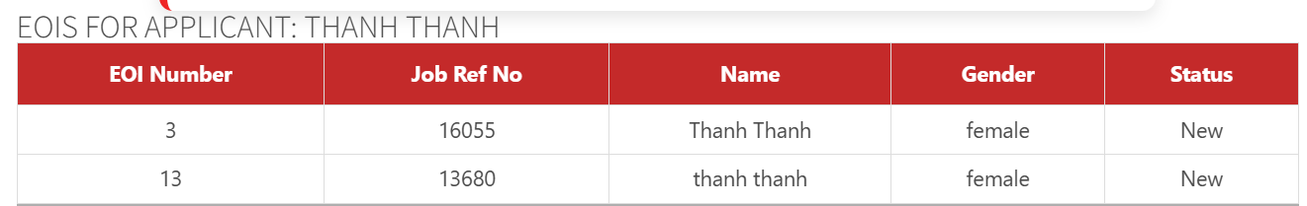

*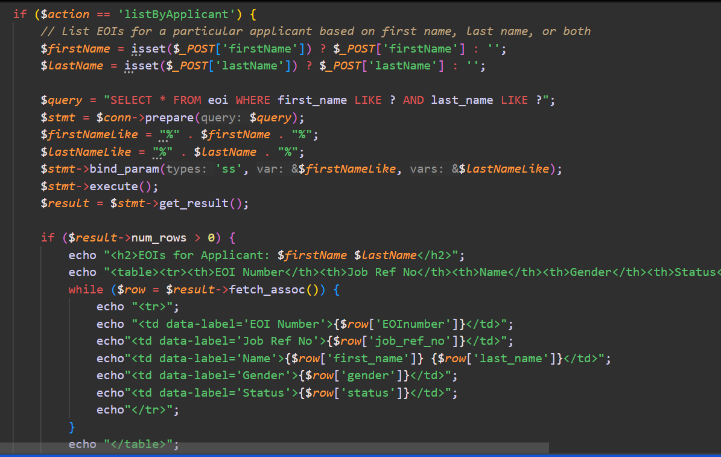figure 35:*

**4. Delete EOIs by Job Reference**

Deletes all EOIs for a given job reference number.

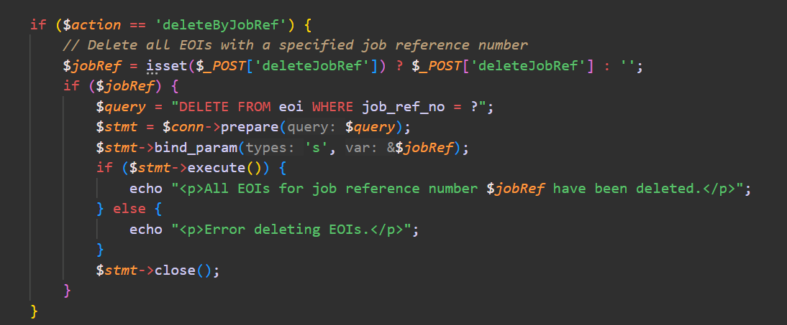

*figure 36:*

**5. Update EOI Status**

Updates the status of a specific EOI by EOInumber.

*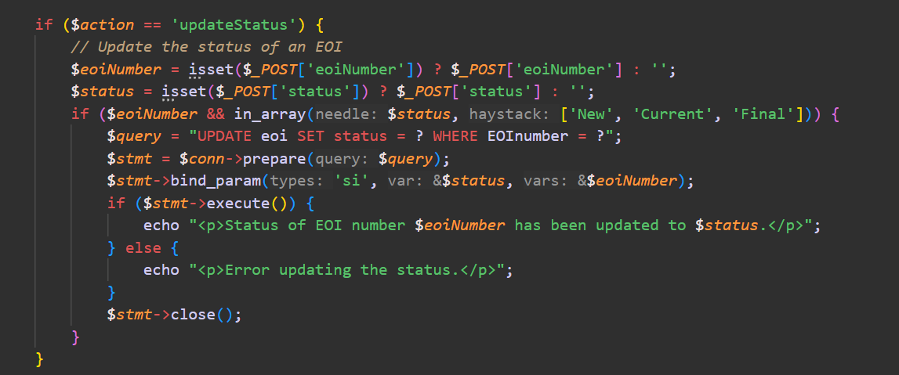figure 37:*

# Security of the website

1. Research using AWS (Amazon web services):
   * + Use AWS Elastic Beanstalk or EC2 for secure hosting:

- Host your website on **AWS Elastic Beanstalk** (simplified deployment) or **Amazon EC2** (customizable virtual servers).

- Configure security groups to:

- Allow only necessary inbound traffic (e.g., HTTP/HTTPS on ports 80 and 443).

- Restrict outbound traffic if not needed.

* + - HTTPS with Amazon Certificate Manager (ACM)

**- Set up SSL/TLS Certificates**:

Use **AWS Certificate Manager** to issue and manage SSL/TLS certificates for free.

Attach the certificate to your load balancer or CloudFront distribution to enforce HTTPS.

**- Redirect HTTP to HTTPS**:

Configure your web server or AWS CloudFront to redirect all traffic to HTTPS.

1. Already Implemented:
   * + **htmlspecialchars():**

Converts special characters (like <, >, &, etc.) into HTML entities to prevent **Cross-Site Scripting (XSS)** attacks. It ensures the output is safe for rendering in a browser.

Example:

<script> would be displayed as &lt;script&gt;, neutralizing any malicious scripts.

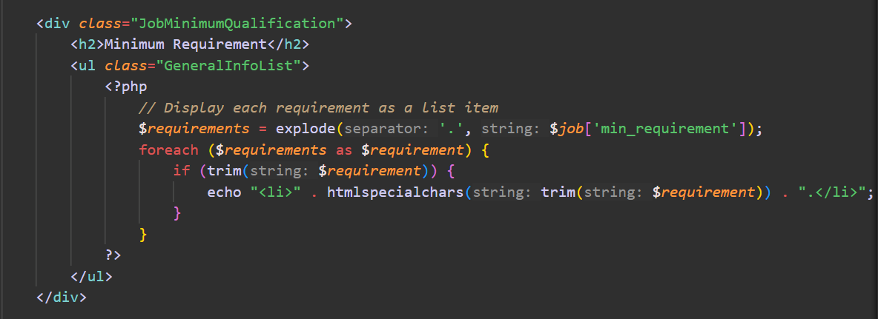*figure 38:*

* + - Strips unnecessary spaces (trim()), backslashes (stripslashes()), and converts special characters (htmlspecialchars()) to prevent XSS attacks.

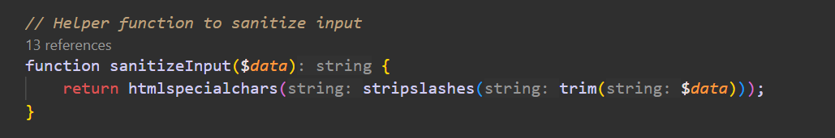*figure 40: sanitized input*

* + - SQL injection prevention with prepared statements.

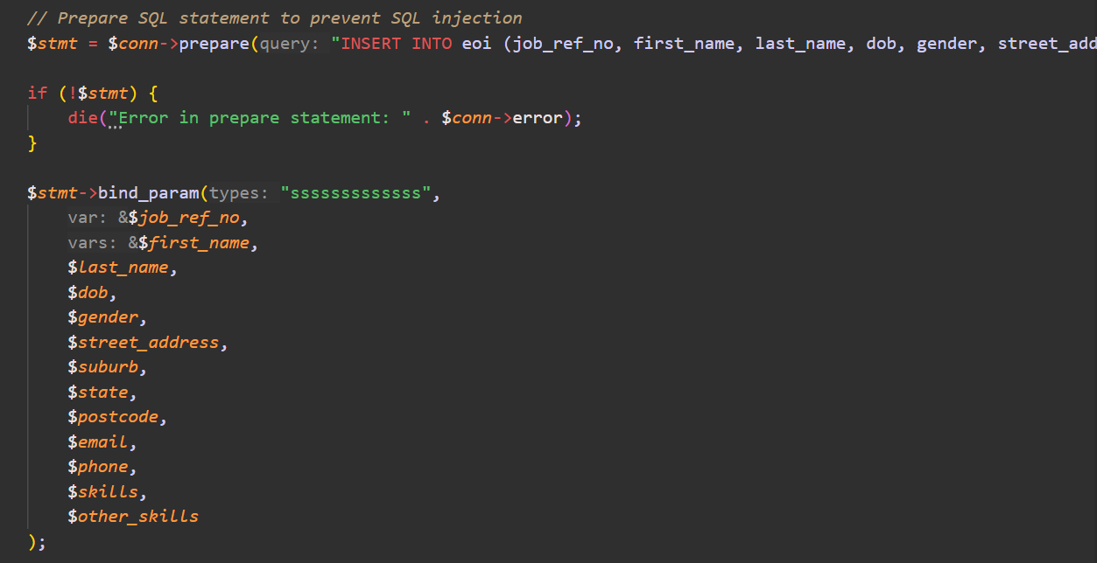*figure 41:*

* + - Password Hashing

*figure 42:*

* + - **Access Control**: The navigation menu and actions adapt to the user's role (admin vs. user). ( as demonstrated previously).

# Your Contribution

As I had said earlier, I do all the enhancements:

* + Reading jobs data from the database
  + Creating login, sign-up, log-out functions, and profile (login-done.php) pages
  + Creating user validations between pages after login

As doing so, I’m being able to achieve these goals:

* Eliminated static job listings, making the website more dynamic and easier to maintain.
* Improved user experience by ensuring that job listings are always up-to-date.
* Enabled scalability: Adding new job opportunities is now a backend task, streamlining the process.
* Provided a secure user authentication system, ensuring only authorized access to sensitive areas (e.g., job application and EOI management).
* Enhanced user engagement by offering tailored content and maintaining user session integrity.
* Created a foundation for additional features, such as user dashboards or admin panels.
* Ensured website security by preventing unauthorized access to sensitive data or features (e.g., EOI management by admins).
* Improved usability by guiding users to their relevant areas based on roles, reducing confusion or potential misuse.
* Built trust among users by safeguarding their private information and activities.

# Reflection and Discussion

1. Professional Purpose

* During this project, I gained valuable insights into the importance of aligning technical skills with broader professional goals. My contributions to the project, including database integration, user authentication, and role-based access control, were driven by the purpose of creating a secure and user-friendly platform. These experiences reinforced the following key lessons:
  + Commitment to Delivering Value: I realized the importance of building features that directly address user needs, such as secure logins and dynamic job listings, ensuring relevance and usability.
  + Problem-Solving Mindset: Debugging code and optimizing security measures highlighted the need for persistence and continuous learning to tackle challenges effectively.
  + Responsibility: By prioritizing security and privacy, I understood my role as a developer in protecting users' data and trust.

1. Teamwork

* Collaboration with Thanh Thanh and Quang Thai highlighted the value of teamwork, where everyone contributed their strengths toward the success of the project.
* **Roles and Contributions**:
  + Thanh Thanh excelled in front-end development, ensuring the website was visually appealing and easy to navigate. She creates all of our images and videos with red themes to fit our website and logo and also the apply page (apply.php and processEOI.php).
  + Quang Thai worked on manage.php and focused on testing and quality assurance, helping us identify and fix bugs efficiently.
  + I worked on backend functionalities and enhancements, including user authentication, database integration, and user role management.
* **Support and Collaboration:**
  + Thanh Thanh's creativity in UI design inspired improvements in backend functionalities to align with user expectations. Quang Thai's thorough testing ensured that the features I developed, like session validations, worked seamlessly.
* **Conflict Resolution**:
  + We occasionally had differing opinions, such as the layout of certain pages or the priority of features. However, we resolved these conflicts through open discussions and democratic decision-making, ensuring all voices were heard.

1. Effective Communication

Communication played a pivotal role in ensuring smooth collaboration and project completion.

* **Regular Updates**: Frequent meetings helped us synchronize our progress. For example, Thanh Thanh shared her designs, which allowed me to integrate them with the backend efficiently. Similarly, I updated the team on database structure changes to ensure compatibility.
* **Constructive Feedback**: Thanh Thanh and Quang Thai provided valuable feedback on my backend implementation, such as improving error messages for login failures, which enhanced the user experience. I also gave feedback on UI elements and workflow logic, ensuring consistency across the platform.
* **Adaptability and Flexibility**: When Thanh Thanh encountered challenges with responsive design or Quang Thai needed more time for testing, we adjusted timelines and supported each other. This flexibility reinforced our teamwork and strengthened the final product.

# Conclusion

In conclusion, this project provided an excellent opportunity for me to showcase my skills in web development and database management while working collaboratively with my team members Thanh Thanh and Quang Thai. Through our combined efforts, we created a dynamic and secure platform that serves as a comprehensive portal for job applications, featuring essential functions such as user authentication, dynamic job listings, and effective role-based access control.

My contributions, particularly in enhancing the backend with database integration and developing user authentication features, helped streamline the website's operations and improve security. Working with Thanh Thanh, who focused on the frontend design, and Quang Thai, who ensured rigorous testing and quality assurance, reinforced the value of teamwork and clear communication. Together, we successfully overcame challenges and integrated our work into a seamless user experience.

Throughout the project, I learned valuable lessons about professional responsibility, problem-solving, and the importance of clear, open communication within a team. The project also highlighted the critical role of security and user trust in web development, which guided many of the decisions I made regarding data protection and privacy.

Overall, this assignment has not only enhanced my technical skills but also provided me with a deeper understanding of the collaborative process in software development. Moving forward, I am more confident in my ability to contribute effectively to team projects and continue building secure, user-friendly systems.

# References

AWS. (2019). *Amazon EC2 Security Groups for Linux Instances - Amazon Elastic Compute Cloud*. Amazon.com. <https://docs.aws.amazon.com/AWSEC2/latest/UserGuide/ec2-security-groups.html>

*Dịch vụ điện toán đám mây miễn phí - Bậc miễn phí của AWS*. (n.d.). Amazon Web Services, Inc. <https://aws.amazon.com/vi/free/?all-free-tier.sort-by=item.additionalFields.SortRank&all-free-tier.sort-order=asc&awsf.Free%20Tier%20Types=>

*How To Setup Amazon EC2 (AWS) To Host Your Websites*. (n.d.). RunCloud Blog. <https://runcloud.io/blog/aws>

*php - Stack Overflow*. (2022, April 22). Stackoverflow.blog. <https://stackoverflow.blog/php/>

*PHP Login Form: A Step by Step Guide to Create Login Form in PHP*. (n.d.). Simplilearn.com. <https://www.simplilearn.com/tutorials/php-tutorial/php-login-form>

*Security in AWS Lambda - AWS Lambda*. (n.d.). Docs.aws.amazon.com. <https://docs.aws.amazon.com/lambda/latest/dg/lambda-security.html>